**Video Transcript**

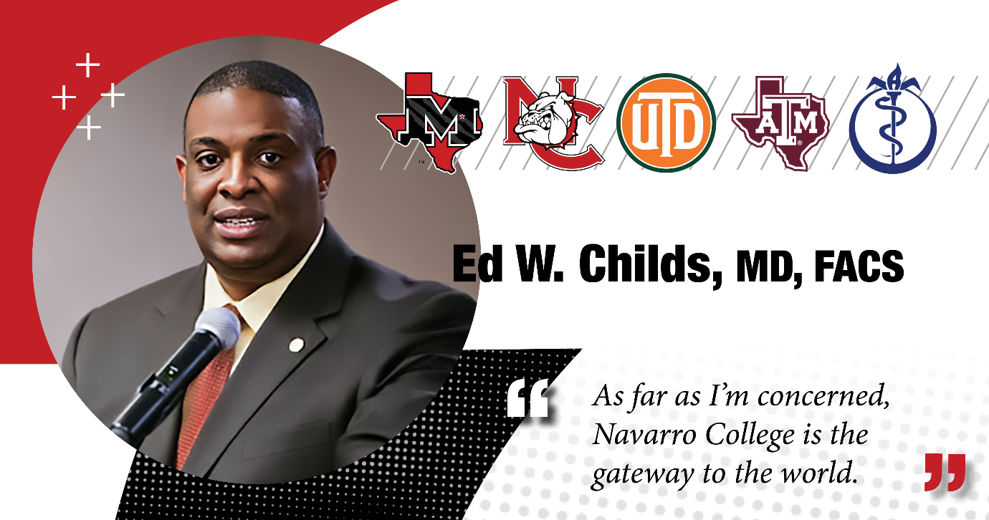

**Text slides on black screen with “Innovation Built on Tradition” tagline on bottom right corner:** What advice would you give to new students?

**Ed Childs:** Any kind of thoughts or advice to any upcoming students? So, first of all, you cannot choose a better College in the world as far as I'm concerned. Um, this has been, you know, I've been all over, I've been many, many countries and all over the U.S. And this by far is the best experience, the most support that you're ever going to find anywhere. And I think it's an excellent opportunity. It's a gateway to the world. So, there's no limits coming to Navarro College. So, I would just keep that in mind for any students coming. It's a gateway to the world.

(Pause)

**Text slides on black screen with “Innovation Built on Tradition” tagline on bottom right corner:** “What were your intentions in choosing Navarro College?”

**Ed Childs**: Uh, first of all, I had no intentions. (chuckle) I, um, Mr. Bill Brown, my high school principal, actually brought me to Navarro College to help me enroll. And from that, I just found my path with the encouragement of Mr. Ken Martin, Dr. Martin, and all of the instructors that I just mentioned. They helped to mold and shape my career. I knew I was always interested in helping people, but I never really talked thought about being a physician. But I merged my love for science with my love for helping and working with people to come up with that career choice.

(Pause)

**Text slides on black screen with “Innovation Built on Tradition” tagline on bottom right corner:** “What was your experience like at Navarro College?”

**Ed Childs**: Navarro College was a wonderful experience for me. I met some of the best friends that I had, was a lifetime of friendship. I met my mentors for life. I met some phenomenal, phenomenal instructors and professors. Um, I always like to refer to them as opportunity makers because they really shape and mold my entire career and I am so grateful for the opportunity to spend time at Navarro College.

(Pause)

**Text Slides on black screen:** Navarro College tagline “Innovation Built on Tradition”

**Text slides under the tagline**: “...It’s a gateway to the world” – Dr. Ed Childs

Navarro College logo appears on the bottom of screen.