# **Carlton McDaniel Video Transcript**

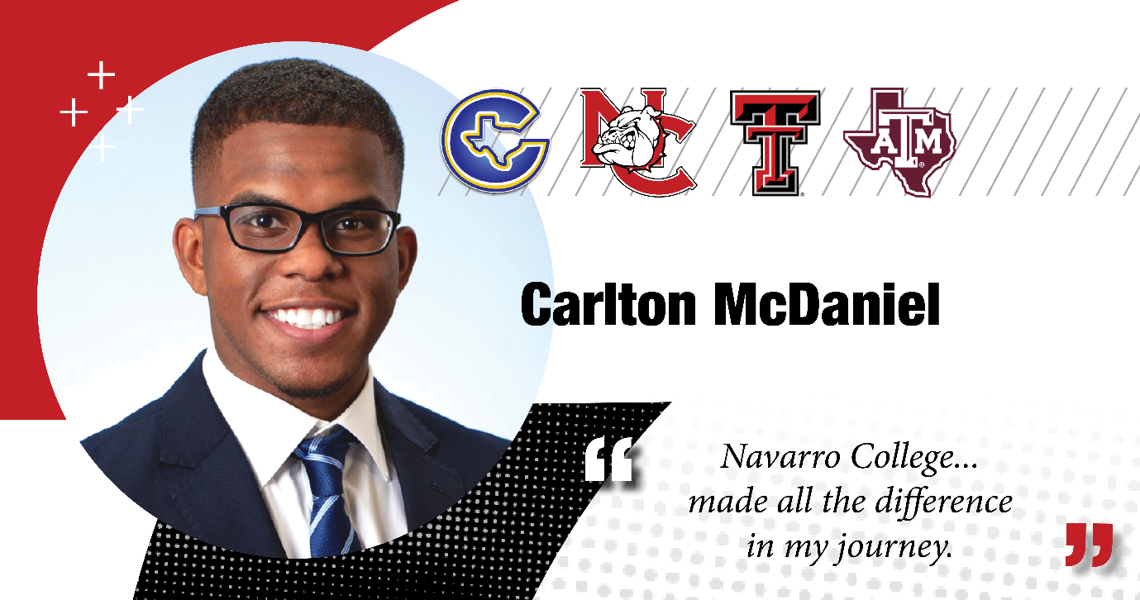

**Carlton McDaniel:** Hello everyone, My name is Carlton McDaniel and 1st off, I'd like to thank Navarro College for giving me the opportunity to share a bit about how my journey has progressed after Navarro College.

So to start us off, I graduated from Navarro in 2019 and I then transferred to Texas Tech University and I majored in Information Technology, and I concentrated in Application Development.

And after Texas Tech, I started my career. I accepted a full-time offer from Lockheed Martin and I'm now a part of Lockheed Martin's Engineering Leadership Development program. And it is a rotational program that's designed to accelerate our technical growth as well as our business acumen. So, we learn various ways on how to show up as a leader each and every day.

And simultaneously, I'm also pursuing a master’s at Texas A&M University where I'm majoring in Information Systems. And the decision to attend Navarro College was pretty simple for me. I was a part of Corsicana High School’s Dual Credit program, so, I was gaining high school credit as well as college credit and that was a great stepping stone to college as well, especially being a first-generation student. And speaking of being a first-generation student, Navarro College offers a TRIO program and TRIO is a program that has an abundant amount of resources rather that’s from financial support to planning what's next at the Navarro College.

So, I highly recommend you check it out if you are planning to attend Navarro College or as a current student at Navarro College. And that's a bit about myself.

Thank you again Navarro College for connecting with me again.