# **Brian Pillans Video Transcript**

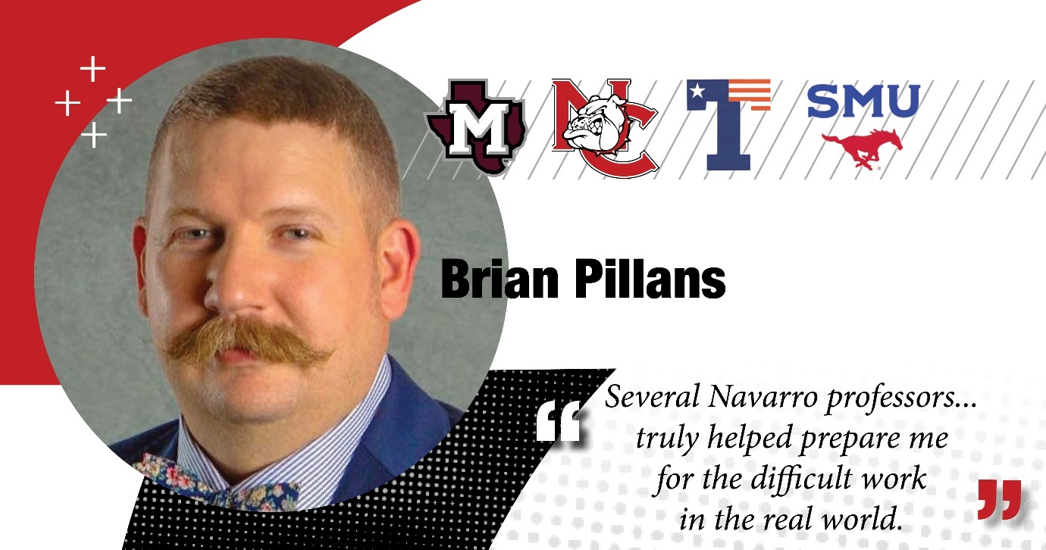

**Brian Pillans:** My name is Brian Pillans, I'm from Corsicana, Texas, and I am currently the Director of Perioperative Services at Baylor Waxahachie.

I think Navarro has been a very important part in my life, um, and I think that it's also an important part of other people's lives because it's a small town community college and it teaches, uh, kids that come out of high school how to study, how to get away from the house, how to live on their own, and it's kind of the start for their career and their life.

Started Navarro College straight out of high school. Uh, once I graduated here at Navarro with an associate’s in science, uh, transferred to the University of Texas at Tyler and that's where I completed nursing school.

Once out of nursing school, I applied to an internship at Baylor University Medical Center in downtown Dallas. I completed that 11-month internship program. From there I was an OR Staff Nurse, which led to an OR Supervisor position and then to an OR Manager position and then transferred down to the Waxahachie campus, which is where I'm currently at my director position.

If you don't know, I'm married to Miss Navarro College, Daniel Pillans, who's one of the speech professors here at the college. Um, we're heavily involved in the students here at Navarro. We try to attend as many sporting events and travel around and, and back everybody as we can.

We also run the college student ministry through our church, and we meet on Sunday nights and provide a meal, as well as Bible study for anybody that wants to come.